NORTH COAST TEACHER INDUCTION PROGRAM

Our mission is to develop a workforce of teachers and school leaders
who engage in research-based practices, understand the importance of preparing students for college and career readiness and have 21st century skills to develop and
implement innovative methods and ideas in the classroom and school.

Registration Tips – Year 1 Candidates

Welcome to a world of ongoing professional learning opportunities with the support of an experienced mentor teacher to assist with the reflection and application of your teaching practice!

Registration Opens August 8, 2016, at http://www.ncsoe.org/
Click on Teacher Induction to get started:

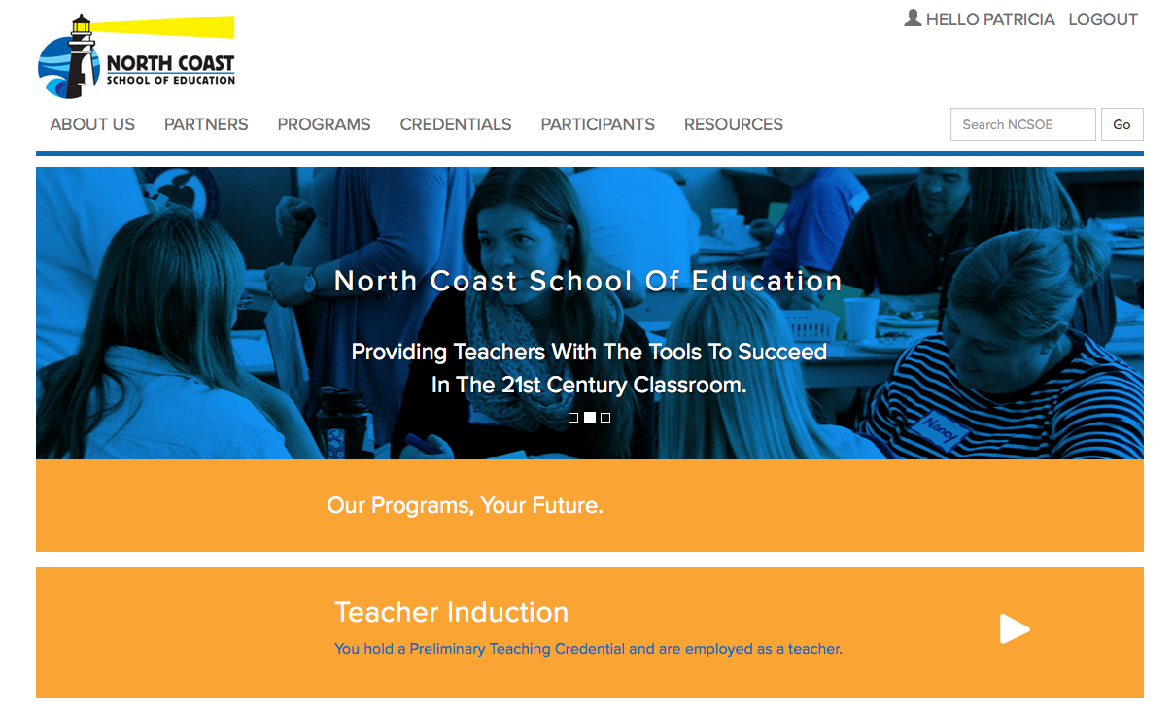

This page provides a brief overview of the Induction program, along with electronic versions of the Course Catalog and Program Overview Brochure. Click on the blue band titled “How to Enroll in Teacher Induction” to open it:

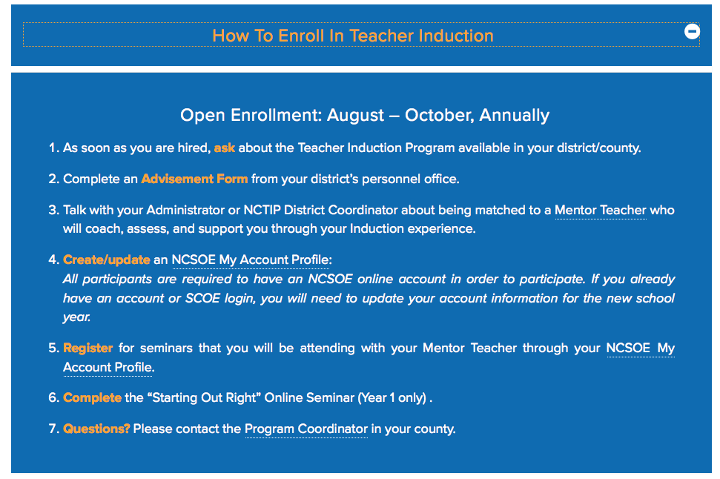

Click on the NCSOE My Account Profile in #4. This will take you to the Login page where you then click on “I don’t have a Login and Password”:

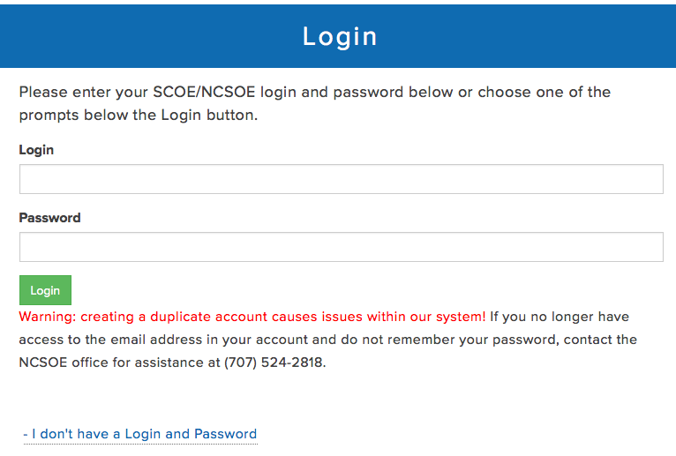

In the next few pages, you will be asked to create a Login and Password, contact information, and Role and Program information for 2016-17.
Role: Candidate – Year 1 (most common)
Program: Induction Year 1 (most common)

You will also need to identify the grades you teach, the credential(s) you hold, plus the County, District, and School you work in. You will need to provide your social security number and date of birth so we can recommend you for your clear credential later. This information is securely provided and kept confidential.

You will be prompted to check two (2) boxes, confirming that you have read and agree to your Roles and Responsibilities and the Failure to Complete Policy. Both of these documents are available by clicking on their titles.

After you press the green button titled “Submit,” you will be directed to the Individual Learning Plan (ILP) where you will use the California Standards for the Teaching Profession (CSTP) to identify two long-term, job-embedded professional growth goals:

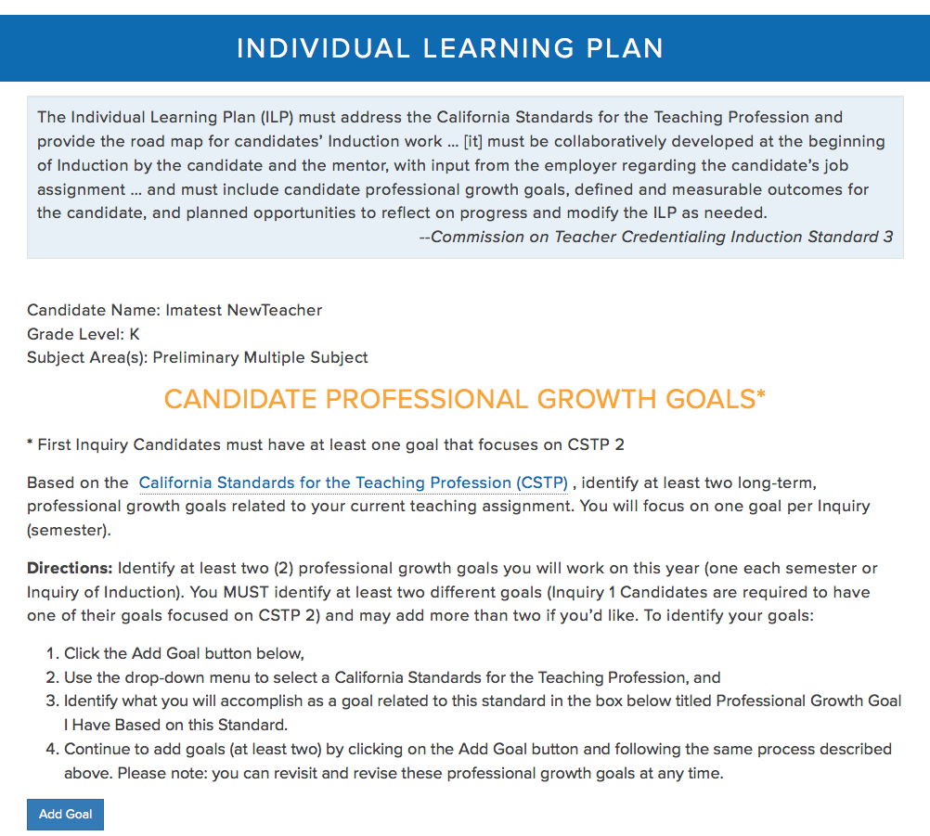

Follow the directions here to choose two CSTP and goals for the year. 1st Inquiry Candidates must choose at least one goal related to CSTP 2. You may revisit and revise these at any time and they will be used as the start of your Individual Learning Plan. Once you choose two goals, a green window appears to prompt you to print them for your work in Induction:

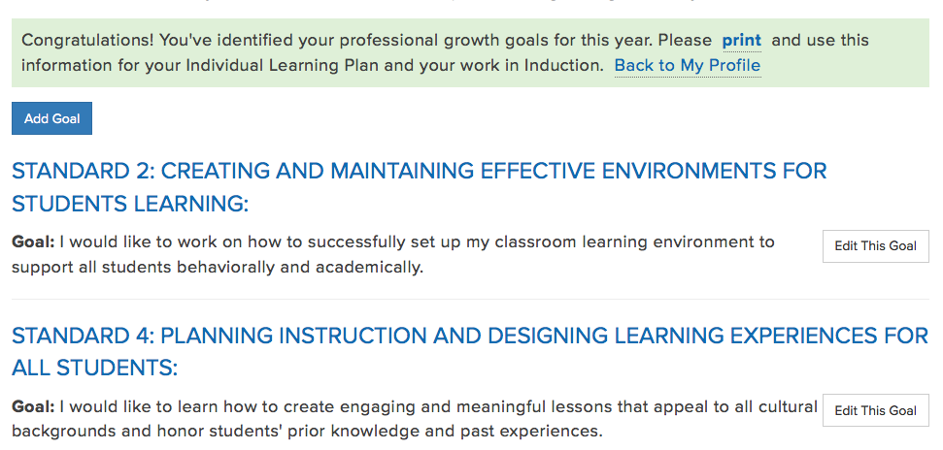

Next, click on “Back to My Profile” as prompted in the green box, and you can Choose Classes/Meetings on the left hand side, review policies, revisit the goals you set above, and more. As the year progresses, this is a good page to check your Attendance and which classes you’ve signed up for:

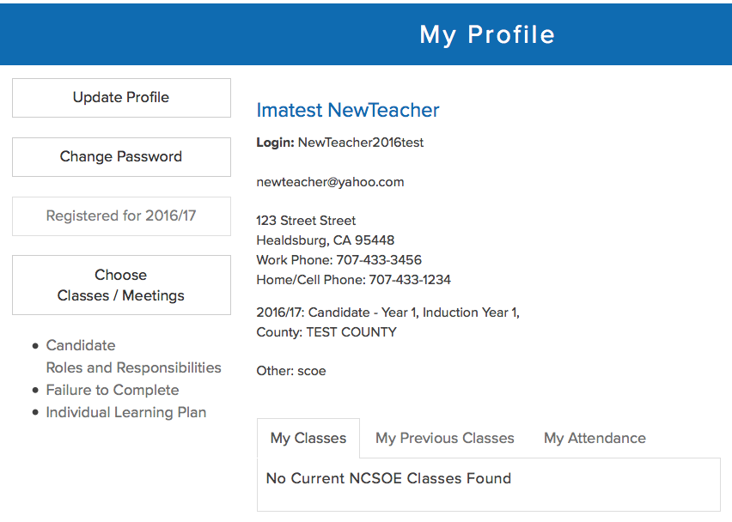

Once registered, you also have access to Program Materials under the Participants tab at the top. In the 4th band down titled “Induction Candidates” you will find information and resources, including your Inquiry 1 and 2 Documents to be submitted as an ePortfolio in Canvas once you are enrolled. While you wait to be enrolled, we encourage you to open and save them to your desktop to review and work on, so you can submit them later.

More Questions?

Patricia Law, Program Coordinator
plaw@scoe.org
(707) 524-2854

