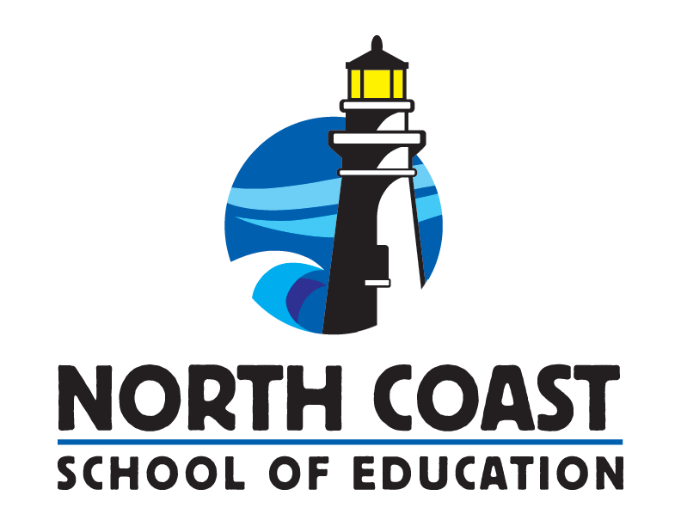
NORTH COAST SCHOOL OF EDUCATION

MENTOR APPLICATION AND SUPPLEMENTAL QUESTIONS

The California Commission on Teacher Credentialing (in accordance with Common Standard 1 and Induction Program Standard 4) requires that the Sonoma County Office of Education’s North Coast School of Education (NCSOE) assure the assignment of qualified Mentors who:

Have knowledge of the context and the content area of Mentees assigned to them, including the current context of public schooling, P-12 content standards, frameworks, and accountability systems

Have knowledge of diversity in society, including diverse abilities, culture, language, ethnicity, and gender orientation

Demonstrate commitment to professional learning and collaboration through effective professional practices in teaching and learning, scholarship and service

Possess a Clear Teaching Credential

Are able, willing and flexible in meeting their Mentee’s need for support

Have a minimum of three years of effective teaching experience on a Clear credential

Mentors should work with their District Coordinator to follow both district and program guidelines for submitting a Mentor Application. In some cases, submitting a letter of interest that details competency in the standards above and the Supplemental Questions below, along with a current resume that covers the components of the application below may be submitted.

The Mentor Application must be submitted both to the district and to NCSOE.
Submitting Your Application to NCSOE:
All new Mentors submit the Mentor application to NCSOE via Canvas, our online learning management system.

Submitting Your Application to your District/Site:
Check with your District Coordinator or Human Resources department for how they would like to best receive your application.

NORTH COAST SCHOOL OF EDUCATION

MENTOR APPLICATION AND SUPPLEMENTAL QUESTIONS
Name: _______________________________________ Phone: _____________________________________
Address: __________________________________________________________________________________
^{Street} ^{City} ^{Zip}
School: _______________________________________ Work Phone: _____________________________
- TEACHING EXPERIENCE (Minimum of 3 years successful teaching experience on Clear):
Dates | District | School | Grade(s) | Subject(s)
CREDENTIAL(S) WITH ENGLISH LEARNER AUTHORIZATION A valid corresponding Clear or Life Credential is required that includes issuance date (list all that apply):
_______________________________________________________________________________________
_______________________________________________________________________________________
- ACADEMIC PREPARATION FOR TEACHING (list most recent first):
Institution | Degree | Dates | Major/Minor

APPLICANT’S STATEMENT:
I would like to participate as a Mentor for the _______________________________ School District and the North Coast School of Education.
Applicant’s Name____________________________________________________________________________

Signature__________________________________________________________ Date_________________

NORTH COAST SCHOOL OF EDUCATION

MENTOR APPLICATION AND SUPPLEMENTAL QUESTIONS
OPTIONAL (Please check with your District Coordinator before completing):
If requested by your district/site, please attach the answers to the following questions.
- How do you stay current on new developments in instruction or the content area in which you teach? How do you self-assess and document your professional growth? Within this question, please address your knowledge of and/or your willingness and commitment to participate in professional development to acquire the knowledge and skills to be an effective Mentor:
- Teacher Performance Expectations
- California Standards for the Teaching Profession
- Common Core State Standards
- State-adopted content standards/curriculum frameworks
- State and local assessments
- Describe your experiences and/or personal qualities that will enhance your role as a Mentor. Within this question, please address your willingness to:
- Share instructional ideas and/or materials with Mentees
- Deepen a Mentee’s understanding of cultural, ethnic, cognitive, linguistic, and gender diversity
- Share your knowledge of beginning teacher development
- Describe your familiarity with and willingness to engage in formative assessment processes, including non-evaluative, reflective conversations about formative assessment evidence with Mentees.
- What are your strengths as a teacher? Within this question, please address your:
- Effectiveness with interpersonal and communication skills (written and oral)
- Willingness to work with new teachers
- Willingness and ability to be an excellent professional role model
- Ability to work with adult learners
- In what ways would you be effective in the role of Mentor?
References: Please list three professional references, including your current principal.
Name | Phone No. | School | Position

