# Sonoma County Office of Education logoNCSOE logoNORTH COAST SCHOOL OF EDUCATION

# Mentor Application

# and Supplemental Questions

decorative line

The California Commission on Teacher Credentialing Common Standard 1 and Induction Program Standard 4 requires the Sonoma County Office of Education’s North Coast School of Education (NCSOE) to assure the assignment of qualified Mentors who:

* Have knowledge of the context and the content area of Candidates assigned to them, including the current context of public schooling, P-12 content standards, frameworks, and accountability systems
* Have knowledge of diversity in society, including diverse abilities, culture, language, ethnicity, and gender orientation
* Demonstrate commitment to professional learning and collaboration through effective professional practices in teaching and learning, scholarship and service
* Possess a Clear Teaching Credential
* Are able, willing and flexible in meeting their Candidate’s need for support
* Have a minimum of three years of effective teaching experience

Mentors should work with their District Coordinator to follow both district and program guidelines for submitting a Mentor Application. In some cases, submitting a letter of interest that details competency in the standards above and the Supplemental Questions below, along with a current resume that covers the components of the application below may be submitted.

*Applications/resumes and supplemental answers/letters of interest must be current within a three-year timeframe and are submitted both to the district and to NCSOE prior to assignment to Candidates/Interns/Permit holders.*

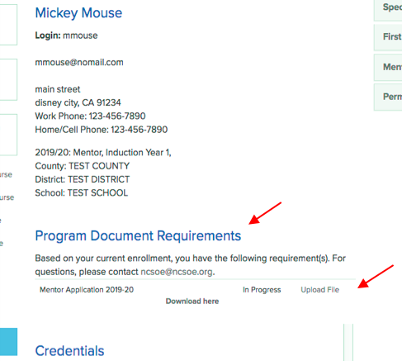Submitting Your Application to NCSOE:

To submit your Mentor application to NCSOE, you will need to upload your document(s) to your NCSOE database account.

1. Make sure you have a digital copy of your application saved on your computer desktop.
2. Log into your NCSOE database account.
3. In the center of your NCSOE Profile page, under the Program Document Requirements section, click the Upload File link. *(If you do not see a Program Document Requirements section on your NCSOE account or the links are not working, please contact the regional office at (707) 524-2818.)*
4. Select the document from your desktop to upload and click submit.

# Sonoma County Office of Education logoNCSOE logoNORTH COAST SCHOOL OF EDUCATION

# Mentor Application

# and Supplemental Questionsdecorative line

Name: _____________________________________ Home Phone: ___________________________________

Home Address: _____________________________________________________________________________

Street City Zip

School: _______________________________________ Work Phone: _____________________________

1. TEACHING EXPERIENCE (Minimum of 3 years successful teaching experience):

|  |  |  |  |  |
| --- | --- | --- | --- | --- |
| Dates | District | School | Grade(s) | Subject(s) |
|  |  |  |  |  |
|  |  |  |  |  |
|  |  |  |  |  |
|  |  |  |  |  |

CREDENTIAL(S) WITH EL AUTHORIZATION:

A valid corresponding Clear or Life Credential is required that includes issuance date (list all that apply).

_______________________________________________________________________________________

_______________________________________________________________________________________

1. ACADEMIC PREPARATION FOR TEACHING (list most recent first):

|  |  |  |  |
| --- | --- | --- | --- |
| Institution | Degree | Dates | Major/Minor |
|  |  |  |  |
|  |  |  |  |
|  |  |  |  |

Applicant’s Statement:  
I would like to participate as a Mentor for the _______________________________ School District and the North Coast School of Education. I have read the Roles and Responsibilities of a Mentor and agree to fulfill them.

Applicant’s Name____________________________________________________________________________

Signature__________________________________________________________ Date_________________

# Sonoma County Office of Education logoNCSOE logoNORTH COAST SCHOOL OF EDUCATION

# Mentor Application

# and Supplemental Questionsdecorative line

OPTIONAL *(Please check with your District Coordinator before completing*):

Please attach the answers to the following questions to your application packet.

1. How do you stay current on new developments in instruction or the content area in which you teach? How do you self-assess and document your professional growth? Within this question please address your knowledge of and/or your willingness and commitment to participate in professional development to acquire the knowledge and skills to be an effective Mentor:

* California Standards for the Teaching Profession
* Common Core State Standards
* State-adopted content standards/curriculum frameworks
* State and local assessments

1. Describe your experiences and/or personal qualities that will enhance your role as a Mentor. Within this question please address your willingness to:

* Share instructional ideas and/or materials with Candidates
* Deepen a Candidate’s understanding of cultural, ethnic, cognitive, linguistic, and gender diversity
* Share your knowledge of beginning teacher development

1. Describe your familiarity with and willingness to engage in formative assessment processes, including non-evaluative, reflective conversations about formative assessment evidence with Candidates.
2. What are your strengths as a teacher? Within this question please address your:

* Effectiveness with interpersonal and communication skills (written and oral)
* Willingness to work with Candidates
* Willingness and ability to be an excellent professional role model
* Ability to work with adult learners

1. In what ways would you be effective in the role of Mentor?

References: Please list three professional references, including your current principal.

|  |  |  |  |
| --- | --- | --- | --- |
| Name | Phone No. | School | Position |
|  |  |  |  |
|  |  |  |  |
|  |  |  |  |